

Dee Brown

“*Bury My Heart at Wounded Knee* Opens your eyes to one of the greatest untold tragedies of all time.”

-The London Gazzetter

“A great testament to the men who lived and died long before our conquest of this land but were so quickly forgotten.”

-The Chicago Metropolitan

“*Bury My Heart at Wounded Knee* is the book that has most changed my viewpoint on history and what it really means to be an American.”

-Shirley Jones, Author

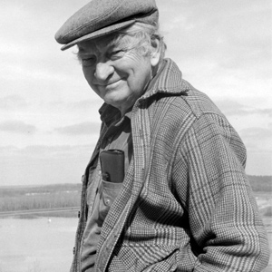

An experienced writer, Dee Brown has written many different books based on the great story of the American westward expansion and the fulfillment of Manifest Destiny. He realized that the story of this great saga was almost entirely based on the experiences of the white man. Raised in Little Rock Arkansas, he had several childhood friends and acquaintances who were native American and wondered about their story.

The saga of the American West, one of the greatest stories of all time is almost always told from the view of the white man. Europeans, new to this harsh wilderness battle their way through savage-infested wilderness in order to make a living for themselves in the land of opportunity. This viewpoint has saturated the media of the United States and is the way most Americans look at this time period. *Bury My Heart at Wounded Knee* was groundbreaking when released because it tells the same story from the viewpoint of the “savages,” that were so feared and hated. It documents the atrocities and broken promises suffered on the Native Americans, people who had occupied and learned the way of this land since before recorded time.

This new edition allows you to re-discover the book that so shocked the world at its 1970 debut. The story of the American West is not without its victims and drama. In this book the story so often ignored is told.